Student Training Session – Microsoft ONEDRIVE

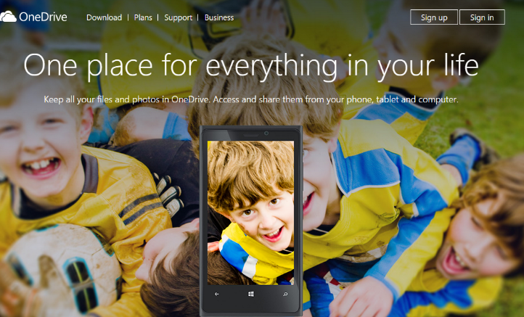
- Step ONE - Click the picture or search MICROSOFT ONEDRIVE in google.

- Click SIGN UP in the right hand corner.

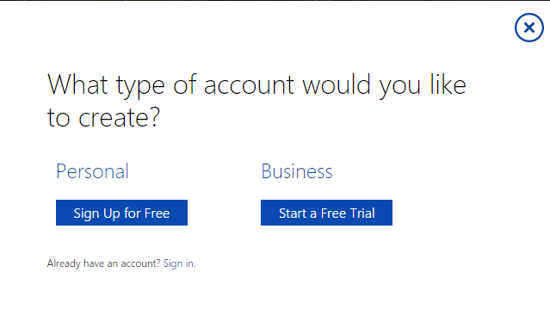

- Select PERSONAL as your preference (Sign up for Free)

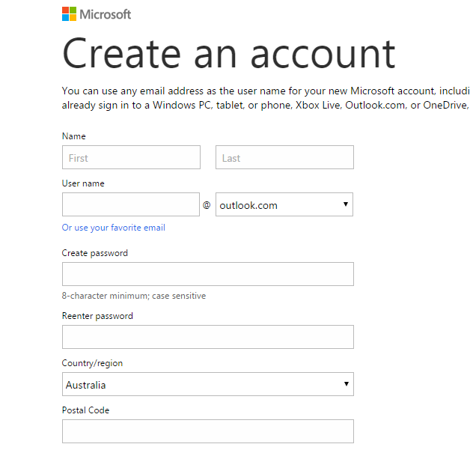

- Create a PASSWORD - 8 character minimum - case sensitive. Write your password somewhere safe. The more random, the better

- UN TICK this box, - you don’t want promotional offers. You don’t have to add a phone number.

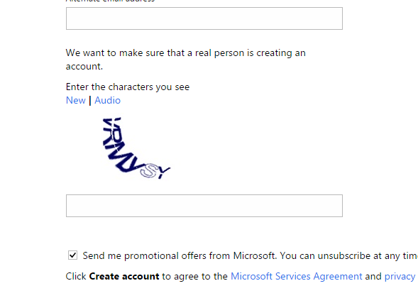

- Enter the characters you see.
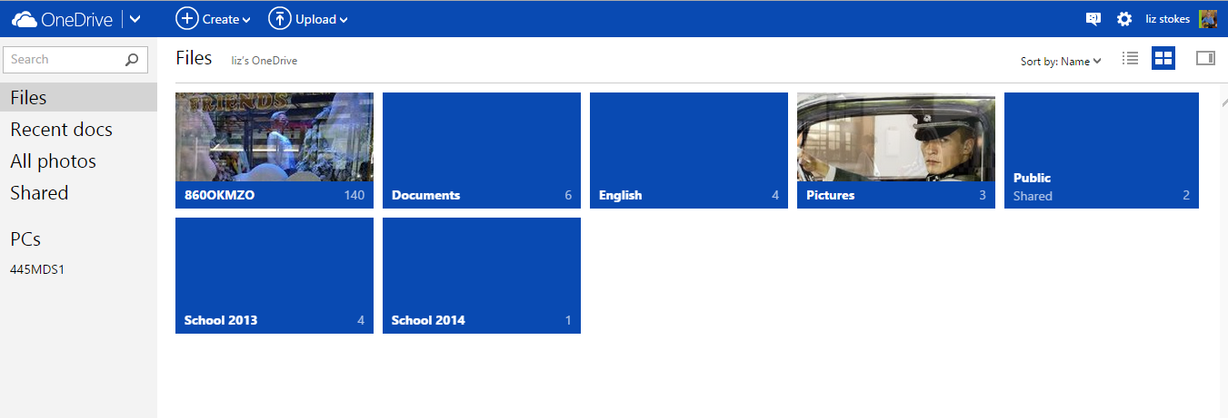
- Once you have created your account, you can access ONEDRIVE.

- Download ONEDRIVE to your personal PC https://onedrive.live.com/about/en-nz/download/

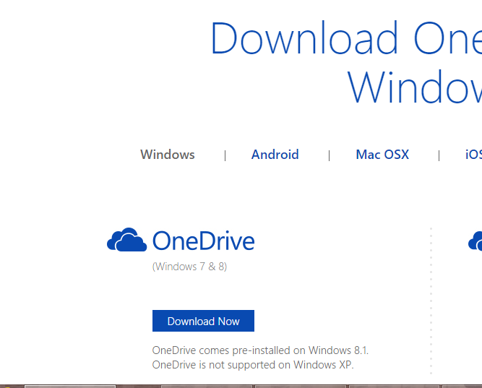

- Follow the installation steps.

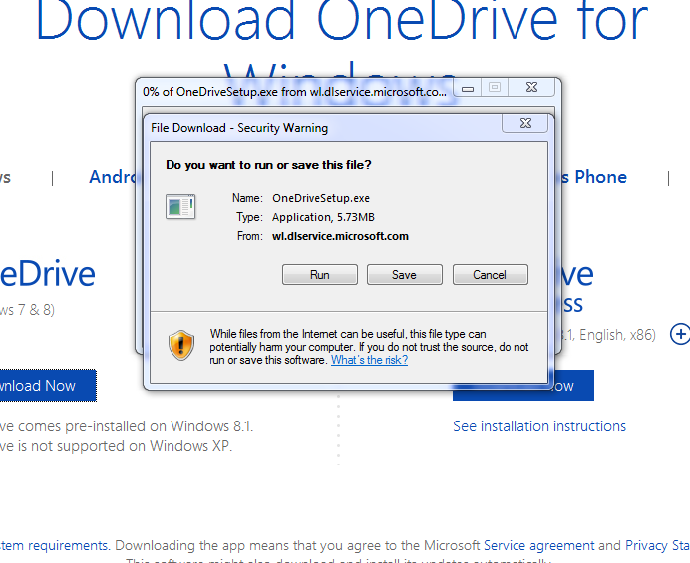

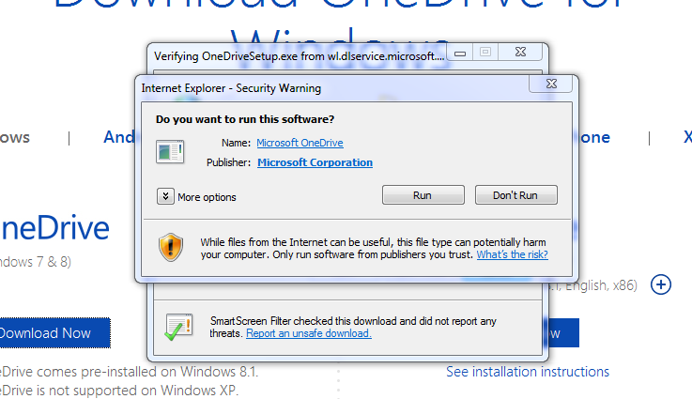
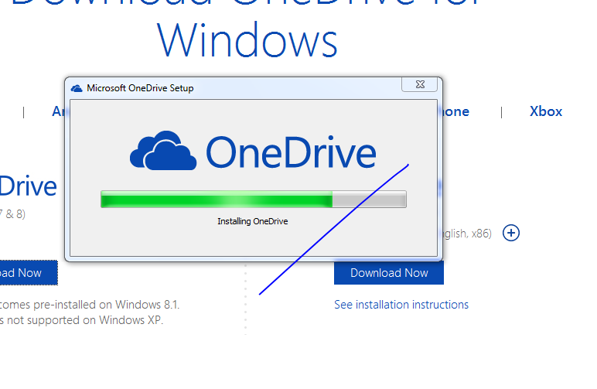
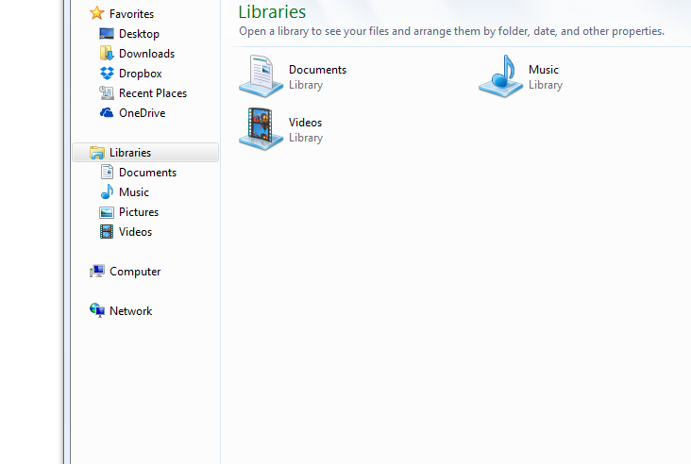
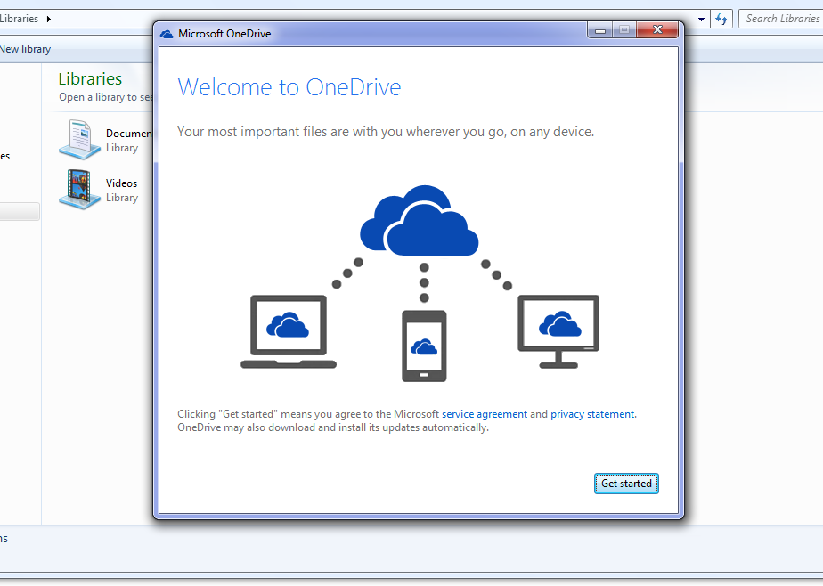
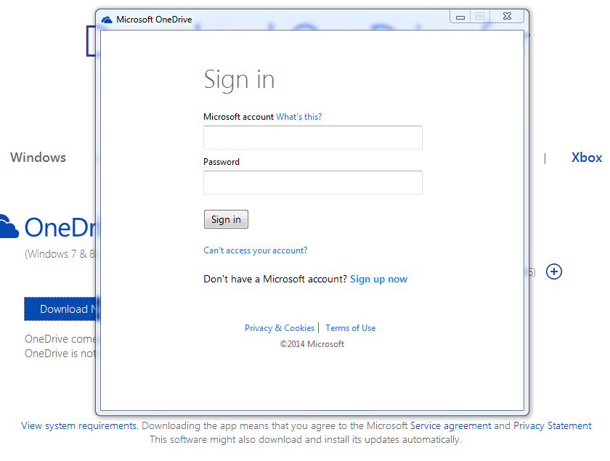

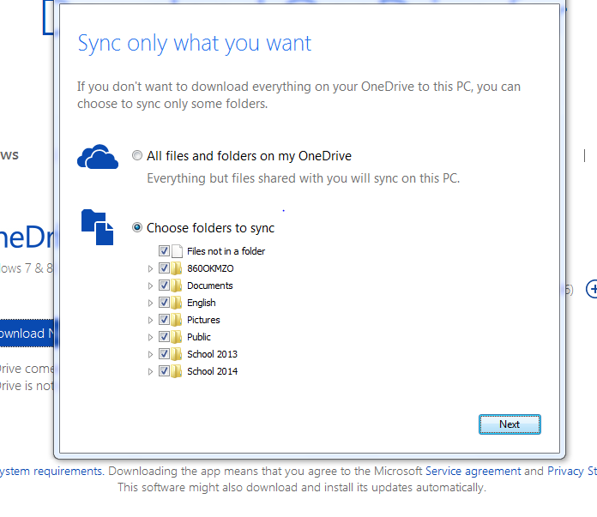

TASKS for Today:

- Create a ONEDRIVE account
- Create new folders in ONEDRIVE. Simply click on CREATE in the top left hand corner. Choose folder and create a folder.
  - Examples include: School 2014 etc.

- Create new folder in ONEDRIVE via the folders tab on your computer.

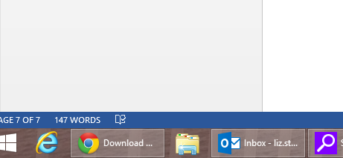

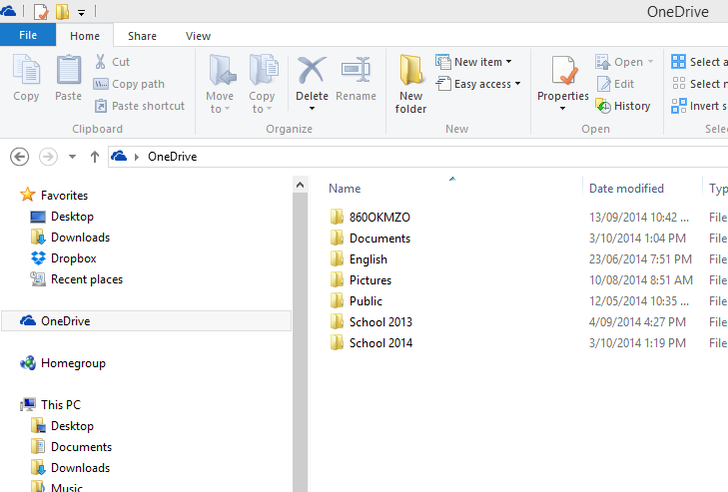
- Select ONEDRIVE - Create new folder.

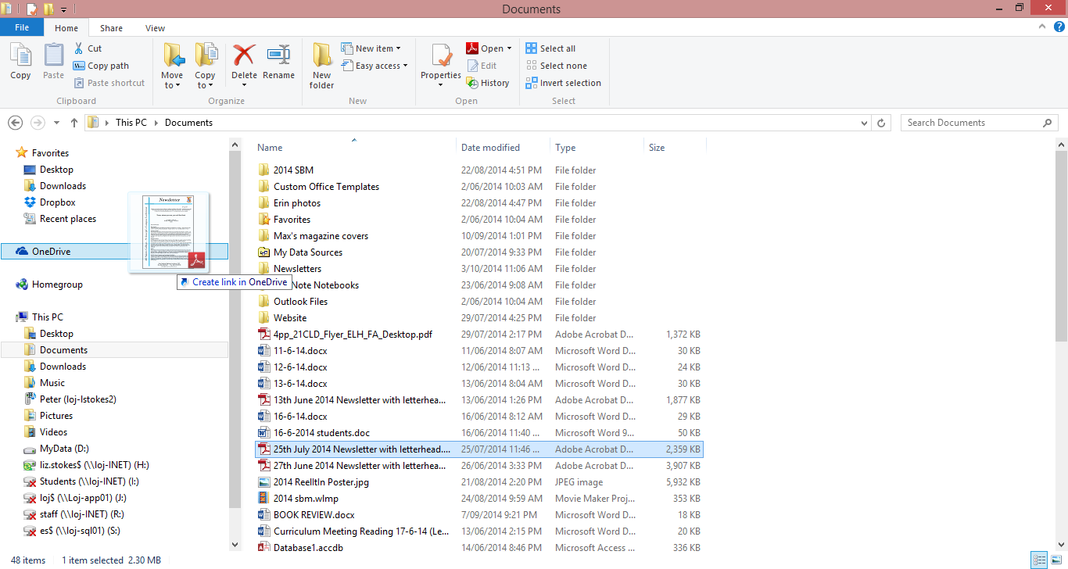
- Transfer a file from your computer to ONEDRIVE (collect a file and drop and drag)
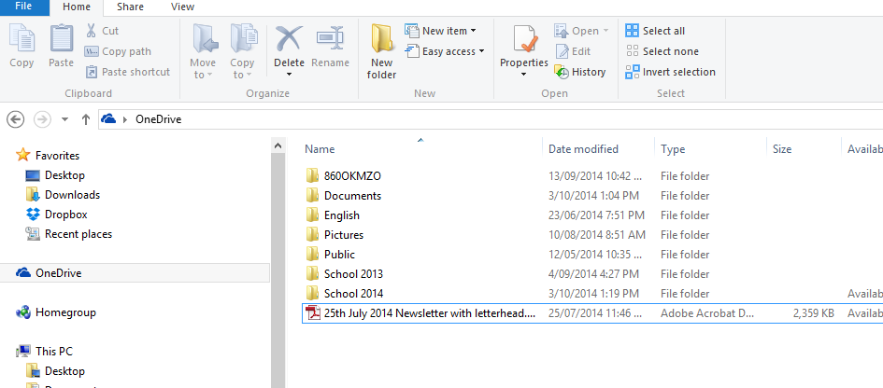
- The document is now available in your ONEDRIVE. Click on SHARE on the ribbon

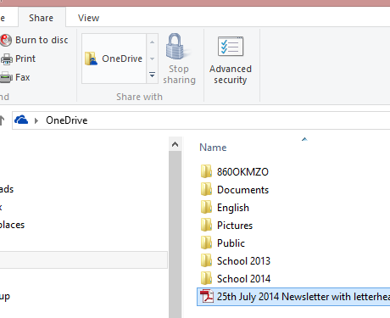
- Select the document you would like to share and click ONEDRIVE on the ribbon. This will take you to the internet and to your ONEDRIVE

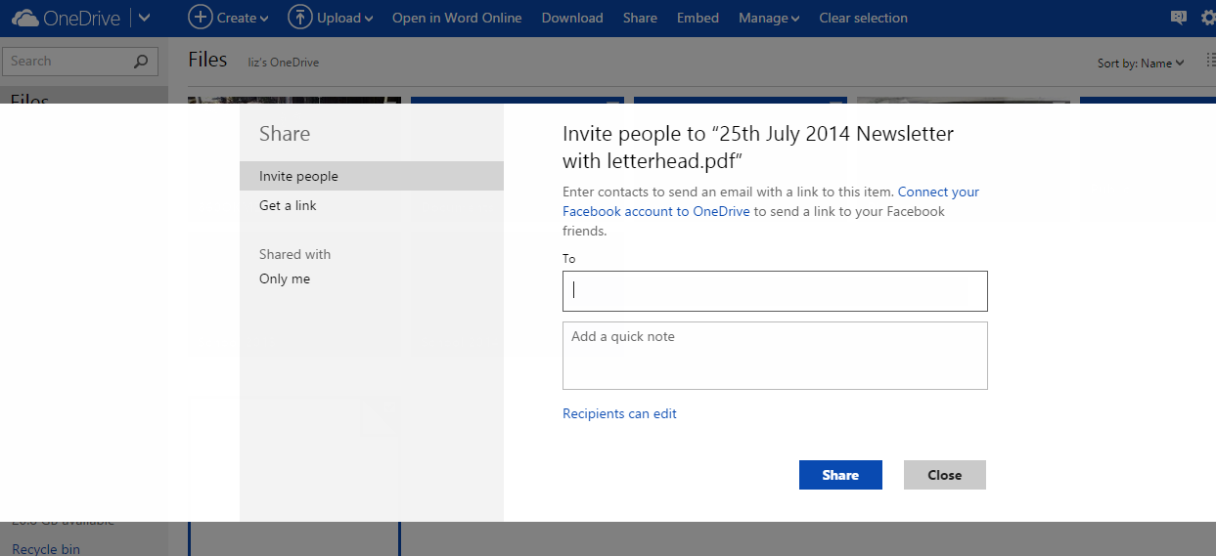
- Email and share your document with someone else in the room. Check to see they received your document.

- Recipients can either EDIT OR VIEW the document.

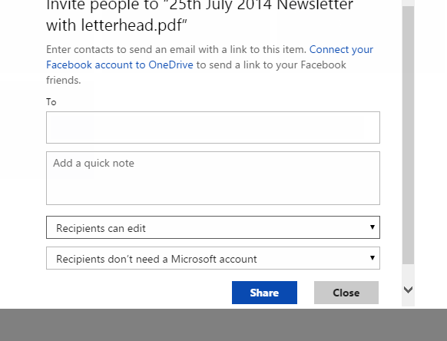
- Check to see if you can receive a document and edit the document you have attached.

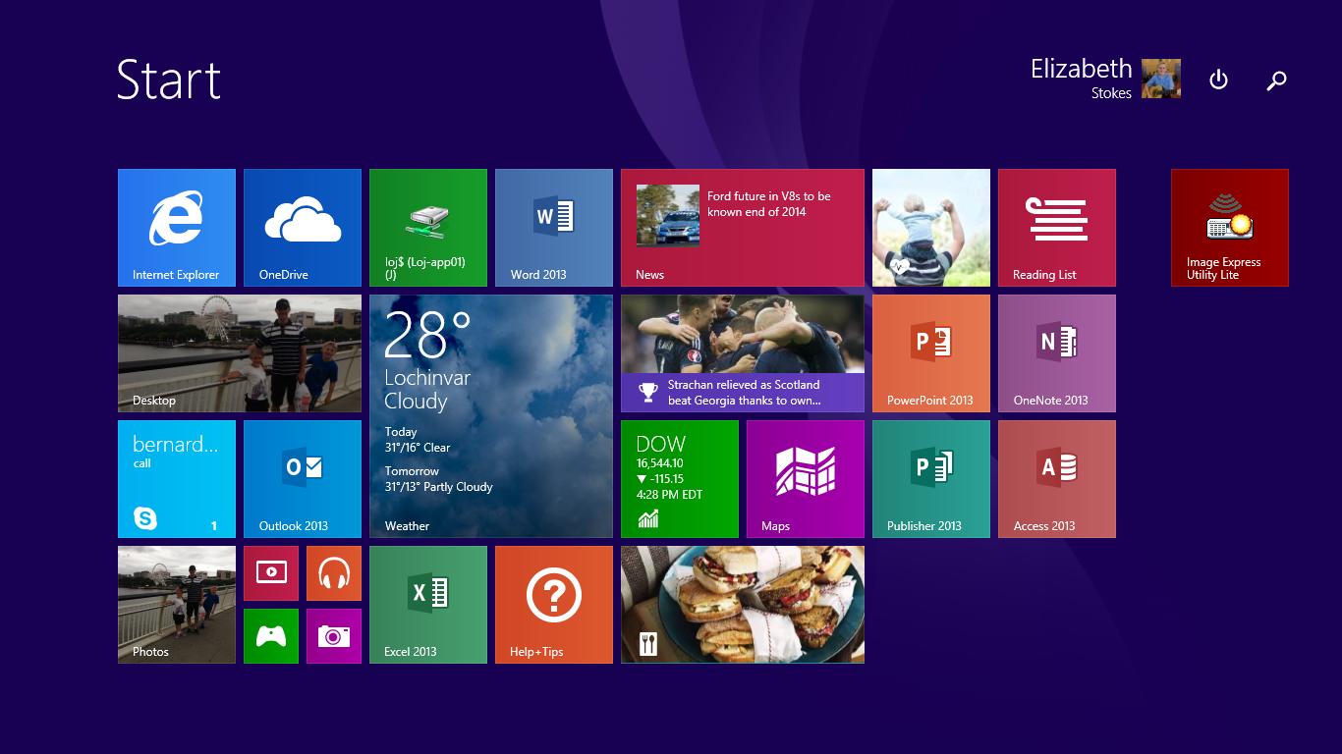
EXTENSION ACTIVITY - Download the APP for ONEDRIVE to your phone/tablet.

